**Department of Systemics**

**School of Computer Science**

University of Petroleum and Energy Studies

cid:image003.png@01D81F60.F8BDA810

**ADVANCE DATABASE MANAGEMENT SYSTEM**

**LAB FILE**

Submitted by

**Akshat Negi**

**R2142220414**

**Batch - 2**

B.Tech Computer Science and Engineering(CSF)

Submitted to

**Dr. KOTHA VENUGOPALCHARY**

Assistant Professor (SS)

SOCS, UPES

**EXPERIMENT-1**

**TITLE: TO UNDERSTAND DDL AND DML COMMANDS**

***Objective****: To understand the concept of designing issues related to the database with creating, populating the tables. Also familiarize students with different ways of manipulation in database.*

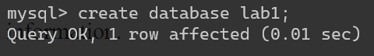

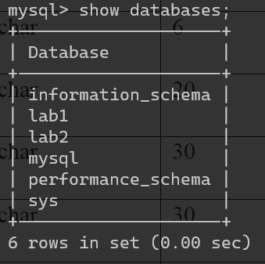

1. Create the tables described below:

**Table name: CLIENT_MASTER Description:** used to store client information.

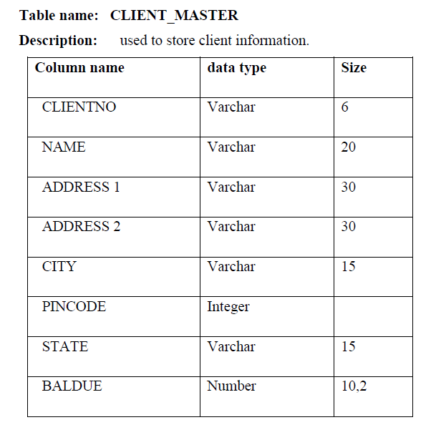

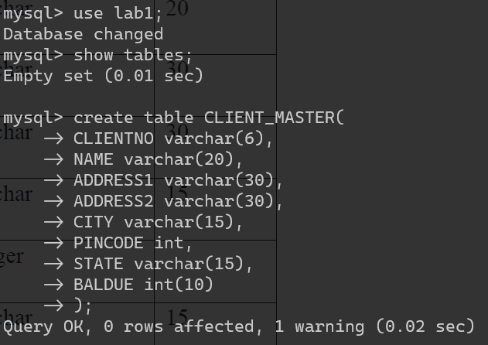

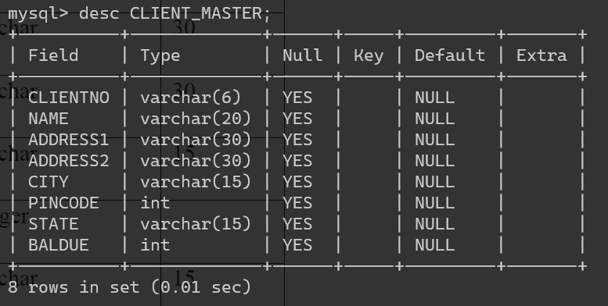

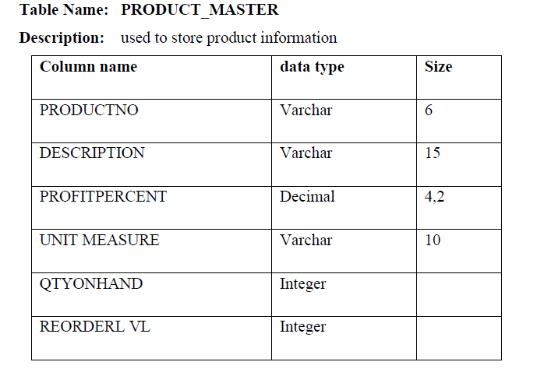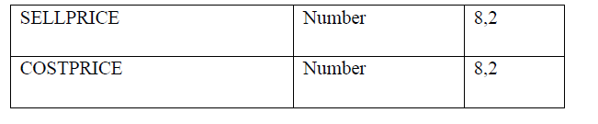

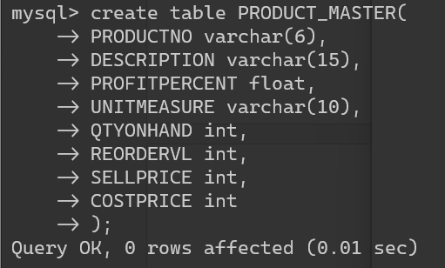

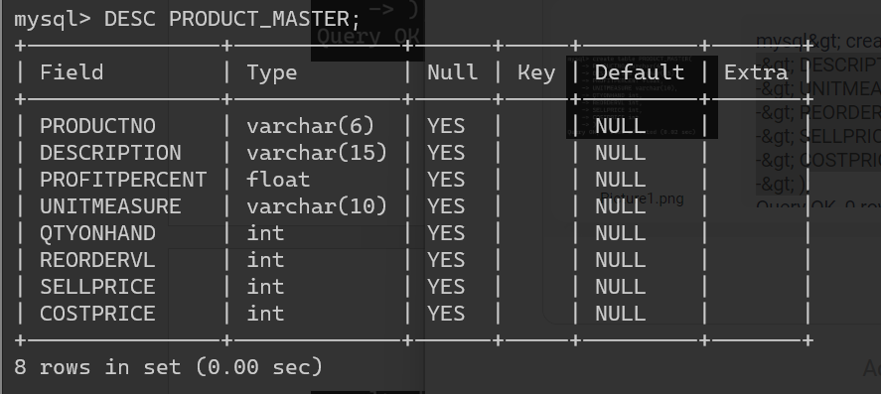

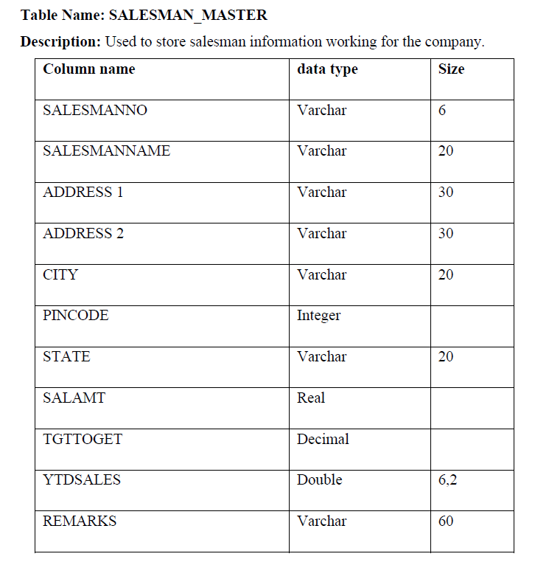 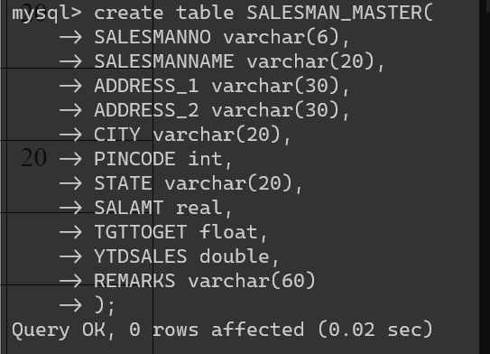

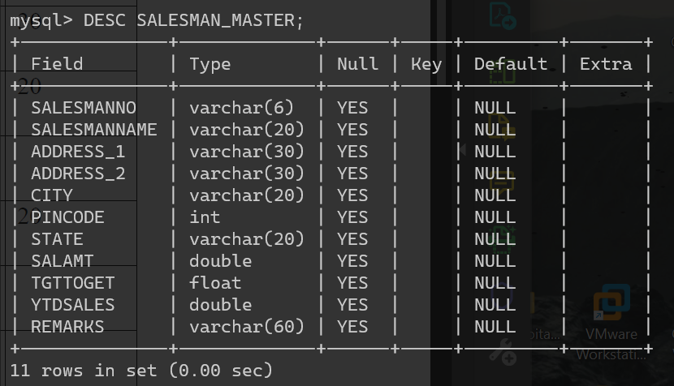

2. Insert the following data into their respective tables:

a) Data for CLIENT_MASTER table:

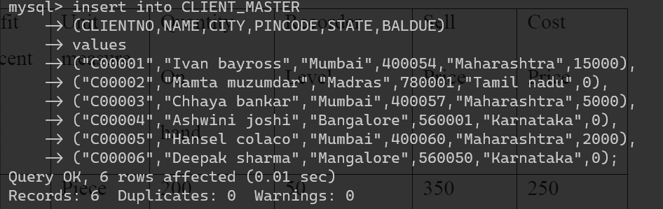

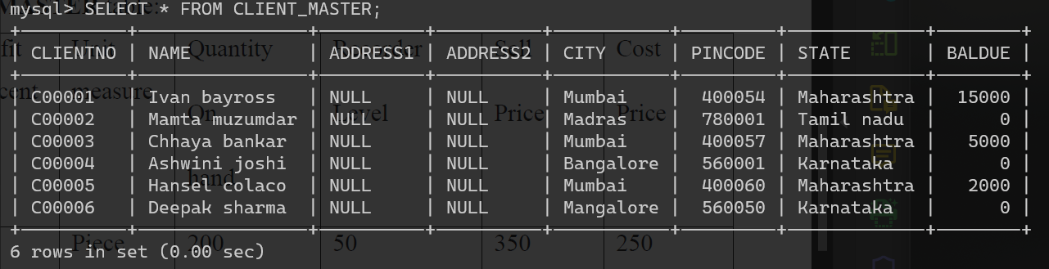

b) Data for PRODUCT_MASTER table:

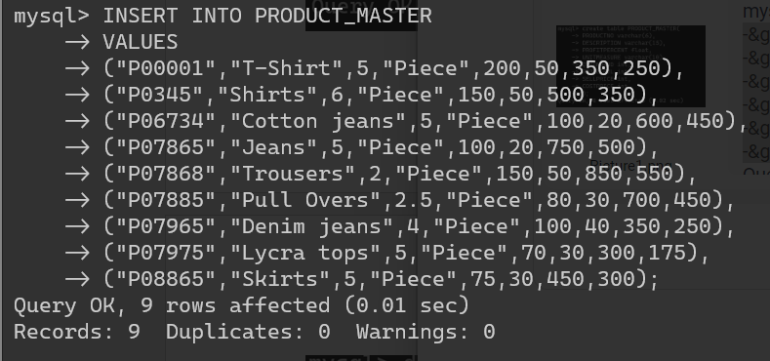

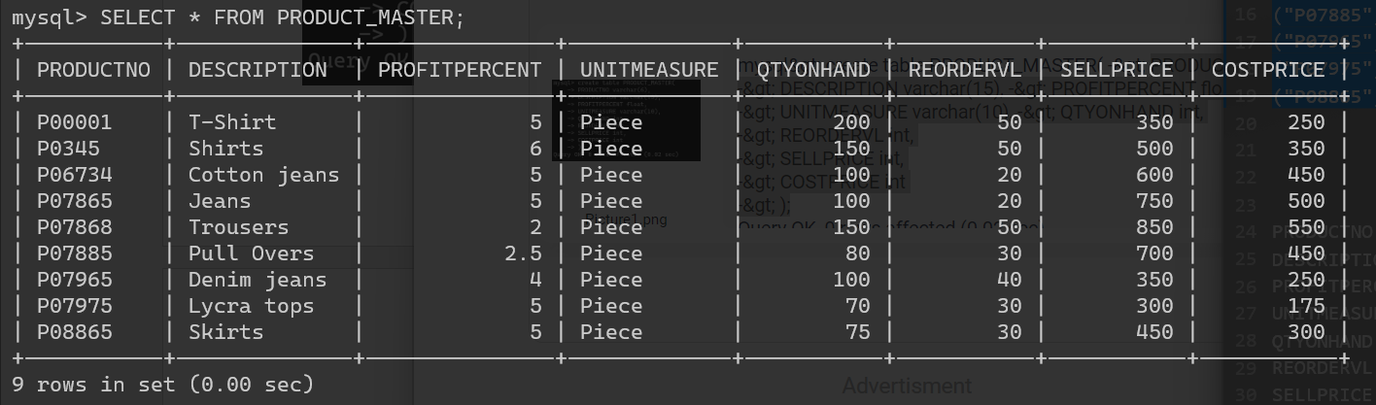

c) Data for SALESMAN_MASTER table:

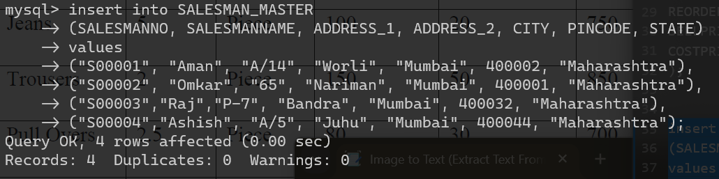

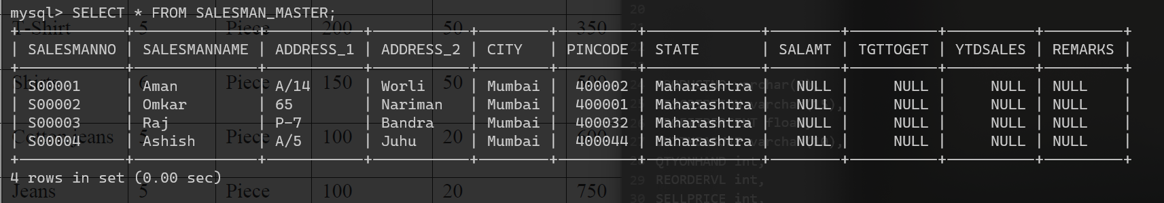

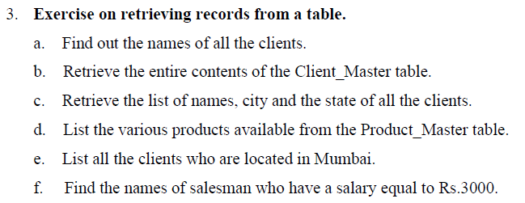

A) Find out the names of all the clients.

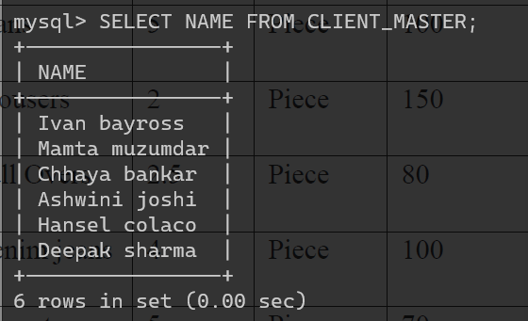

b. Retrieve the entire contents of the Client_Master table.

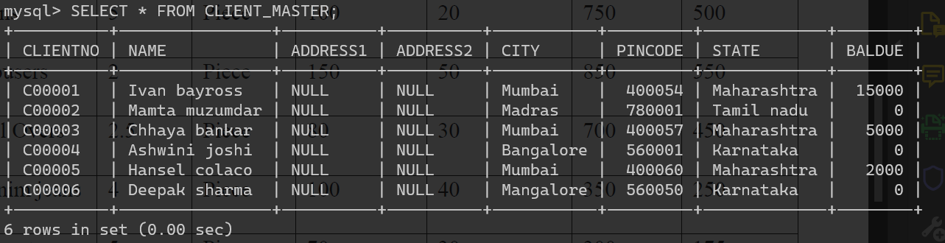

c. Retrieve the list of names, city and the state of all the clients.

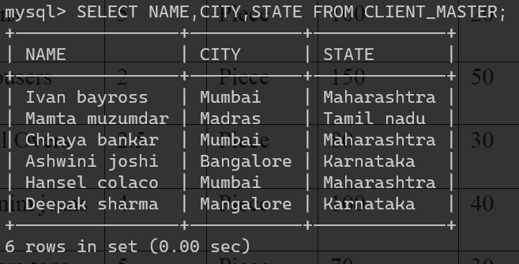

d. List the various products available from the Product_Master table.

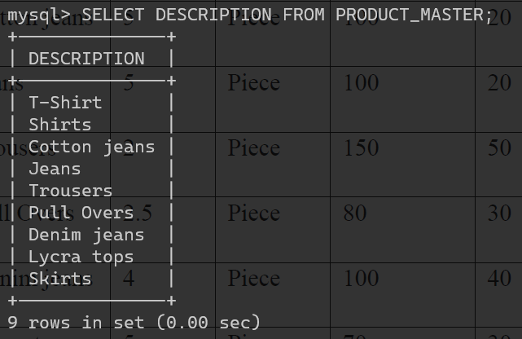

e. List all the clients who are located in Mumbai.

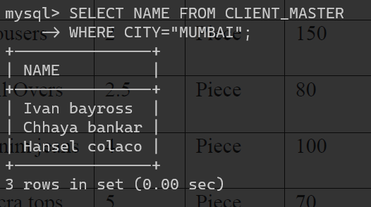

f. Find the names of salesman who have a salary equal to Rs.3000.

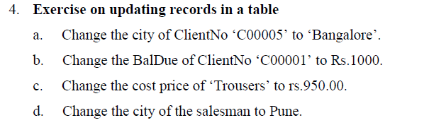

a. Change the city of ClientNo ‘C00005’ to ‘Bangalore’.

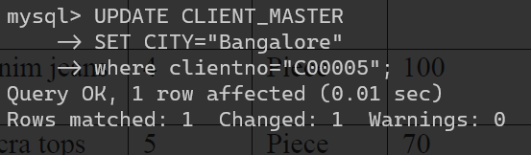

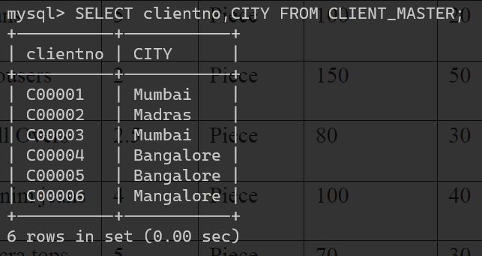

b. Change the BalDue of ClientNo ‘C00001’ to Rs.1000.

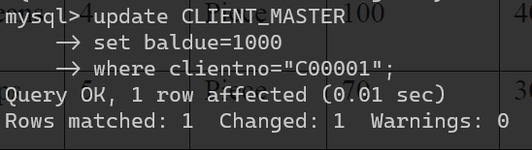

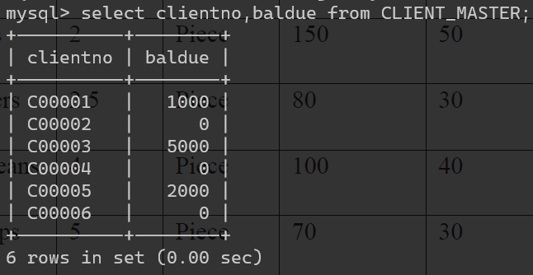

c. Change the cost price of ‘Trousers’ to rs.950.00.

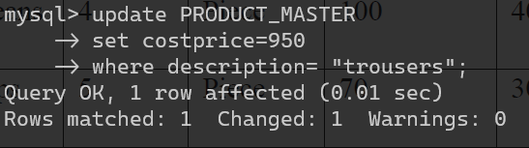

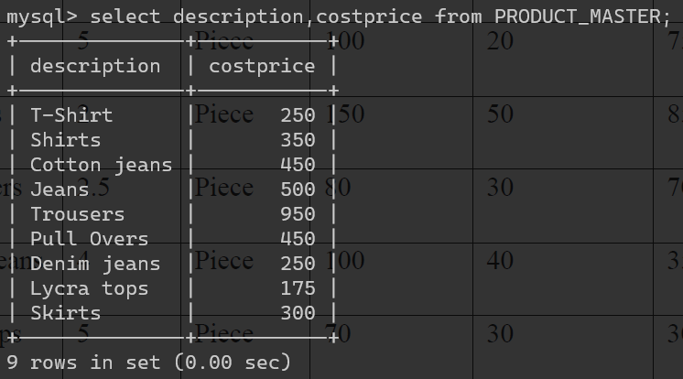

d. Change the city of the salesman to Pune.

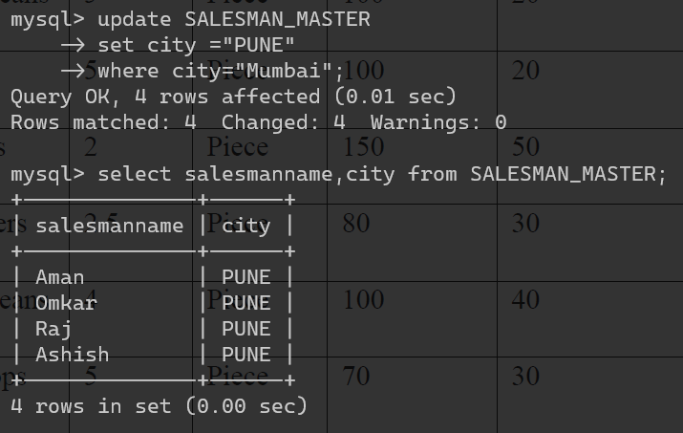

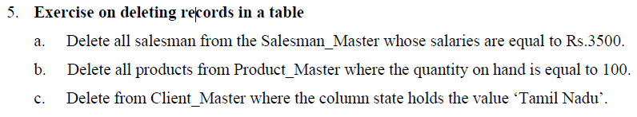

a. Delete all salesman from the Salesman_Master whose salaries are equal to Rs.3500.

b. Delete all products from Product_Master where the quantity on hand is equal to 100.

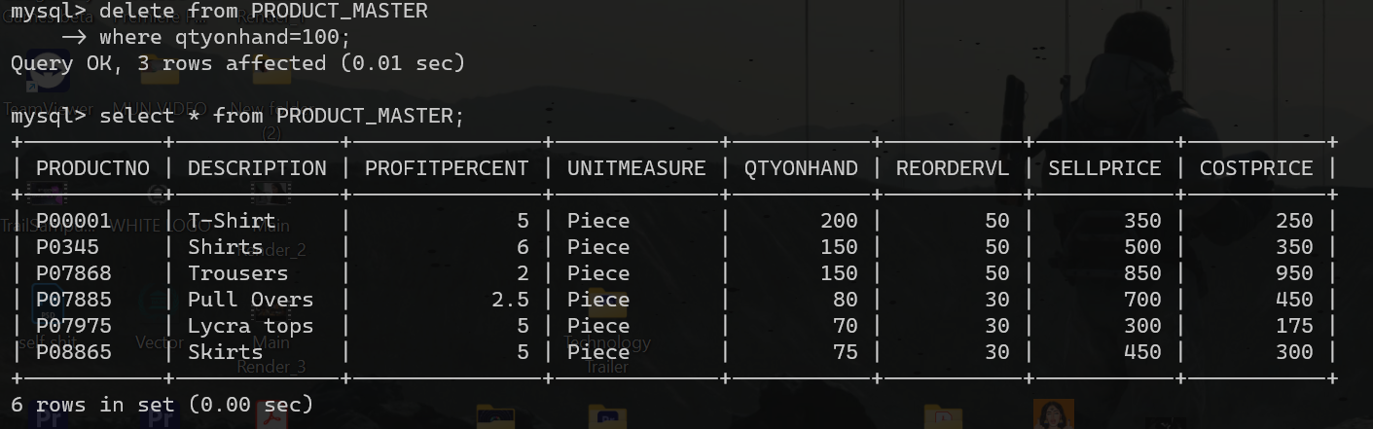

c. Delete from Client_Master where the column state holds the value ‘Tamil Nadu’.

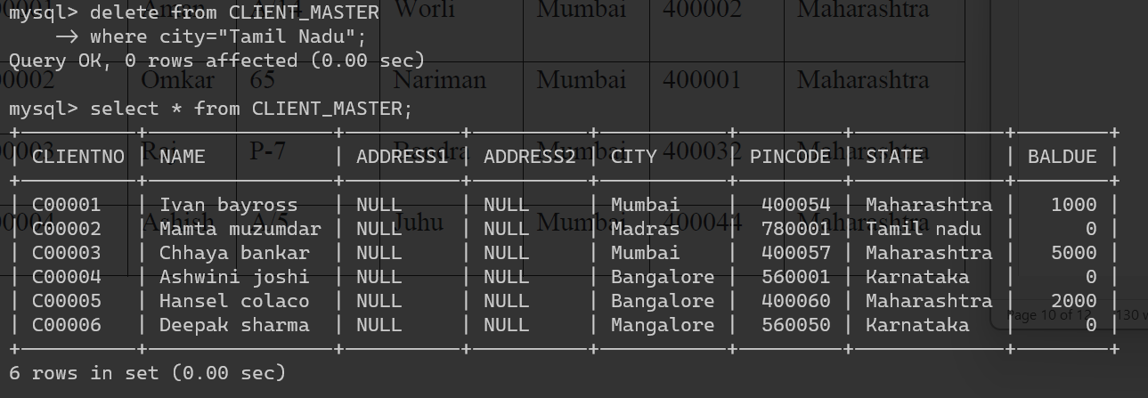

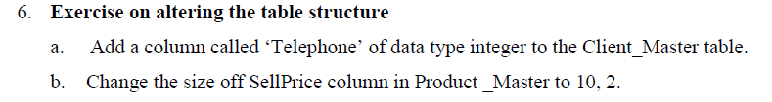

a. Add a column called ‘Telephone’ of data type integer to the Client_Master table.

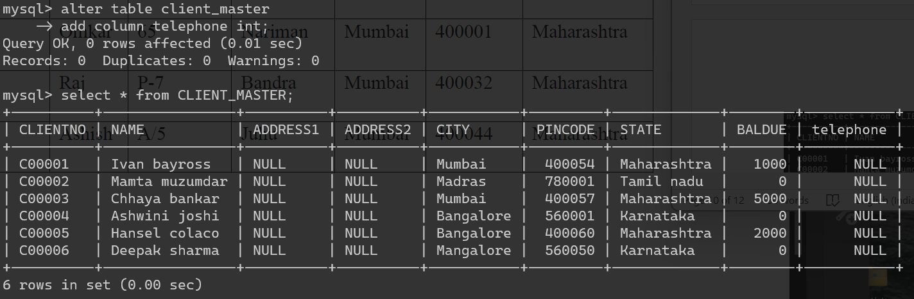

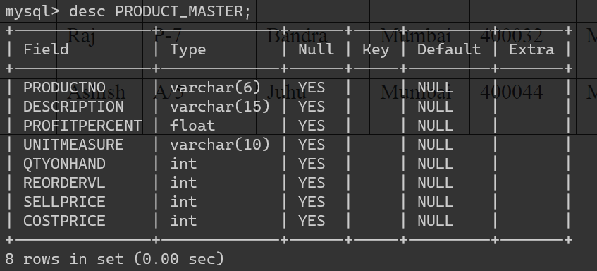

b. Change the size off SellPrice column in Product _Master to 10, 2.

